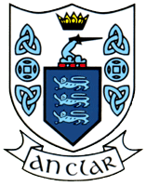

**Clare Coaching & Games**

**January 25th 2018**

**Award 1 Youth Football Coaching Course**

A Chara,

Clare Coaching & Games will deliver an Award 1 Coaching Courses club coaches

T**his will be hugely beneficial for coaches involved with underage teams.**

The Course will be mainly practically based and will cover a multitude of areas involved in Coaching young players and all coaches wishing to do the course must have completed the Foundation award. The following areas will be covered in the course:

The Power of 10 Coaching Model

Role of the Coach Communication

Technical Proficiency

Tactical Awareness & Playing Facts

Team Play

Physical Literacy & Life Style

Psychological Focus & Communication

The aim of the course is to cover all the areas required in helping young players develop to their potential.

The course is 15 hours in total and will take place over 3 evenings & 3 Sundays mornings (practical session) at the end of which participants will receive an Award 1 Child Coaching Certificate. It is important that all clubs avail of this opportunity to up-skill their coaches and clubs are asked to send in Coaches currently involved with underage teams.

***Coaching Competencies to be developed***  
  
By the end of this course participants will be able to:

* Identify the 6 How to Coach Skills
* Build Rapport, Observe, Analyse, Explain, Provide Demonstration and Provide Positive Feedback to Players
* Identify the position of the Coach of each of the different playing groups in the Coach Education Programme
* Participants will be identify and define the components of the OTú Model
* Identify the key roles, skills and qualities of a Coach
* Be able to define Technical Proficiency for the child player
* Be able to identify different types of activities which can be used to develop Technical Proficiency
* Define Tactical Prowess in Gaelic games for children
* Identify the decisions the child player make on and off the ball
* Identify the types of activity that can be used to develop Tactical Prowess
* Define Team Play in Gaelic games for children
* Identify the ABC’s and RJT’s of Physical Literacy
* Be able to define Playing Facts for children

***Course Philosophy***  
The GAA is committed to implementing an integrated Coach Education Programme with a view to maximising participation, optimising playing standards and ensuring that player’s needs are catered for in a balanced way.  
  
The course is designed to promote the development of the How to Coach skills through modelling of best practice, as demonstrated by the tutor, experimental learning and through the guided reflection on previous experiences – as a coach, player, official or parent – facilitated by the tutor

Course schedule

Friday 23rd February 19.00 St Breckans GAA Club Hse - Introduction & OTu Model/Role of Coach

Friday 2nd March 19.00 St Breckans GAA Club Hse - Physical Literacy & Life Style

Sunday 11th March 10am St Breckans GAA Club Hse - Technical Proficiency & Playing Facts

Sunday 25th March 10am St Breckans GAA Club Hse – Tactical Awareness & Communication

Sunday 15th April 10am St Btreckans GAA Club Hse – Team Play Rules

Friday 27th April 19.00 St Breckans GAA Club Hse - Conclusion & Psychological Focus

To book a place on this course clubs must contact Sean Chaplin

083-1014430 Or Sean.chaplin.gpo.clare@gaa.ie

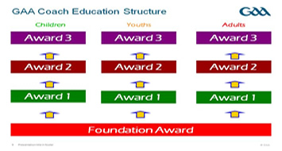

Regards,

John Enright

G.D.A. West Clare

Mob: 083 1015566

Email: john.enright.gpo.clare@gaa.ie